BizTrack360 — Javeria Haroon Branch Artifacts
Branch: frontend | Responsibility: Frontend / User Interface

Purpose of This File
This file contains the SRS artifacts most directly useful for designing user-facing pages, dashboards, task interactions, notifications, status displays and role-specific workflows.

Source
This file is derived from the submitted BizTrack360 Software Requirements Specification (SRS). The artifact descriptions and diagrams below preserve the SRS terminology and content.

Branch Artifact List
- 1. Use Case Diagram
- 2. Sequence Diagram
- 3. Activity Diagram — Task Workflow
- 4. State Chart Diagram — Task Lifecycle

1. Use Case Diagram

Purpose / Description
Describes how the main BizTrack360 users interact with the system and the major functions available to them.

Detailed Artifact Content from the SRS
- Actors: Business Owner, Administrator, Manager, Employee, Investors.
- Managing user accounts and permissions.
- Assigning and tracking tasks.
- Monitoring performance matrix.
- Reviewing financial summaries.
- Accessing reports and analysis.
- The use cases provide the functional view that can guide screens, dashboards, forms and user navigation.

Related SRS Requirements
- Authentication is required before system access.
- Administrators manage roles and permissions.
- The system calculates/displays KPI results.
- Authorized users can access financial summaries.
- Users can securely access documents and reports.

Original Diagram from SRS (Page 15)
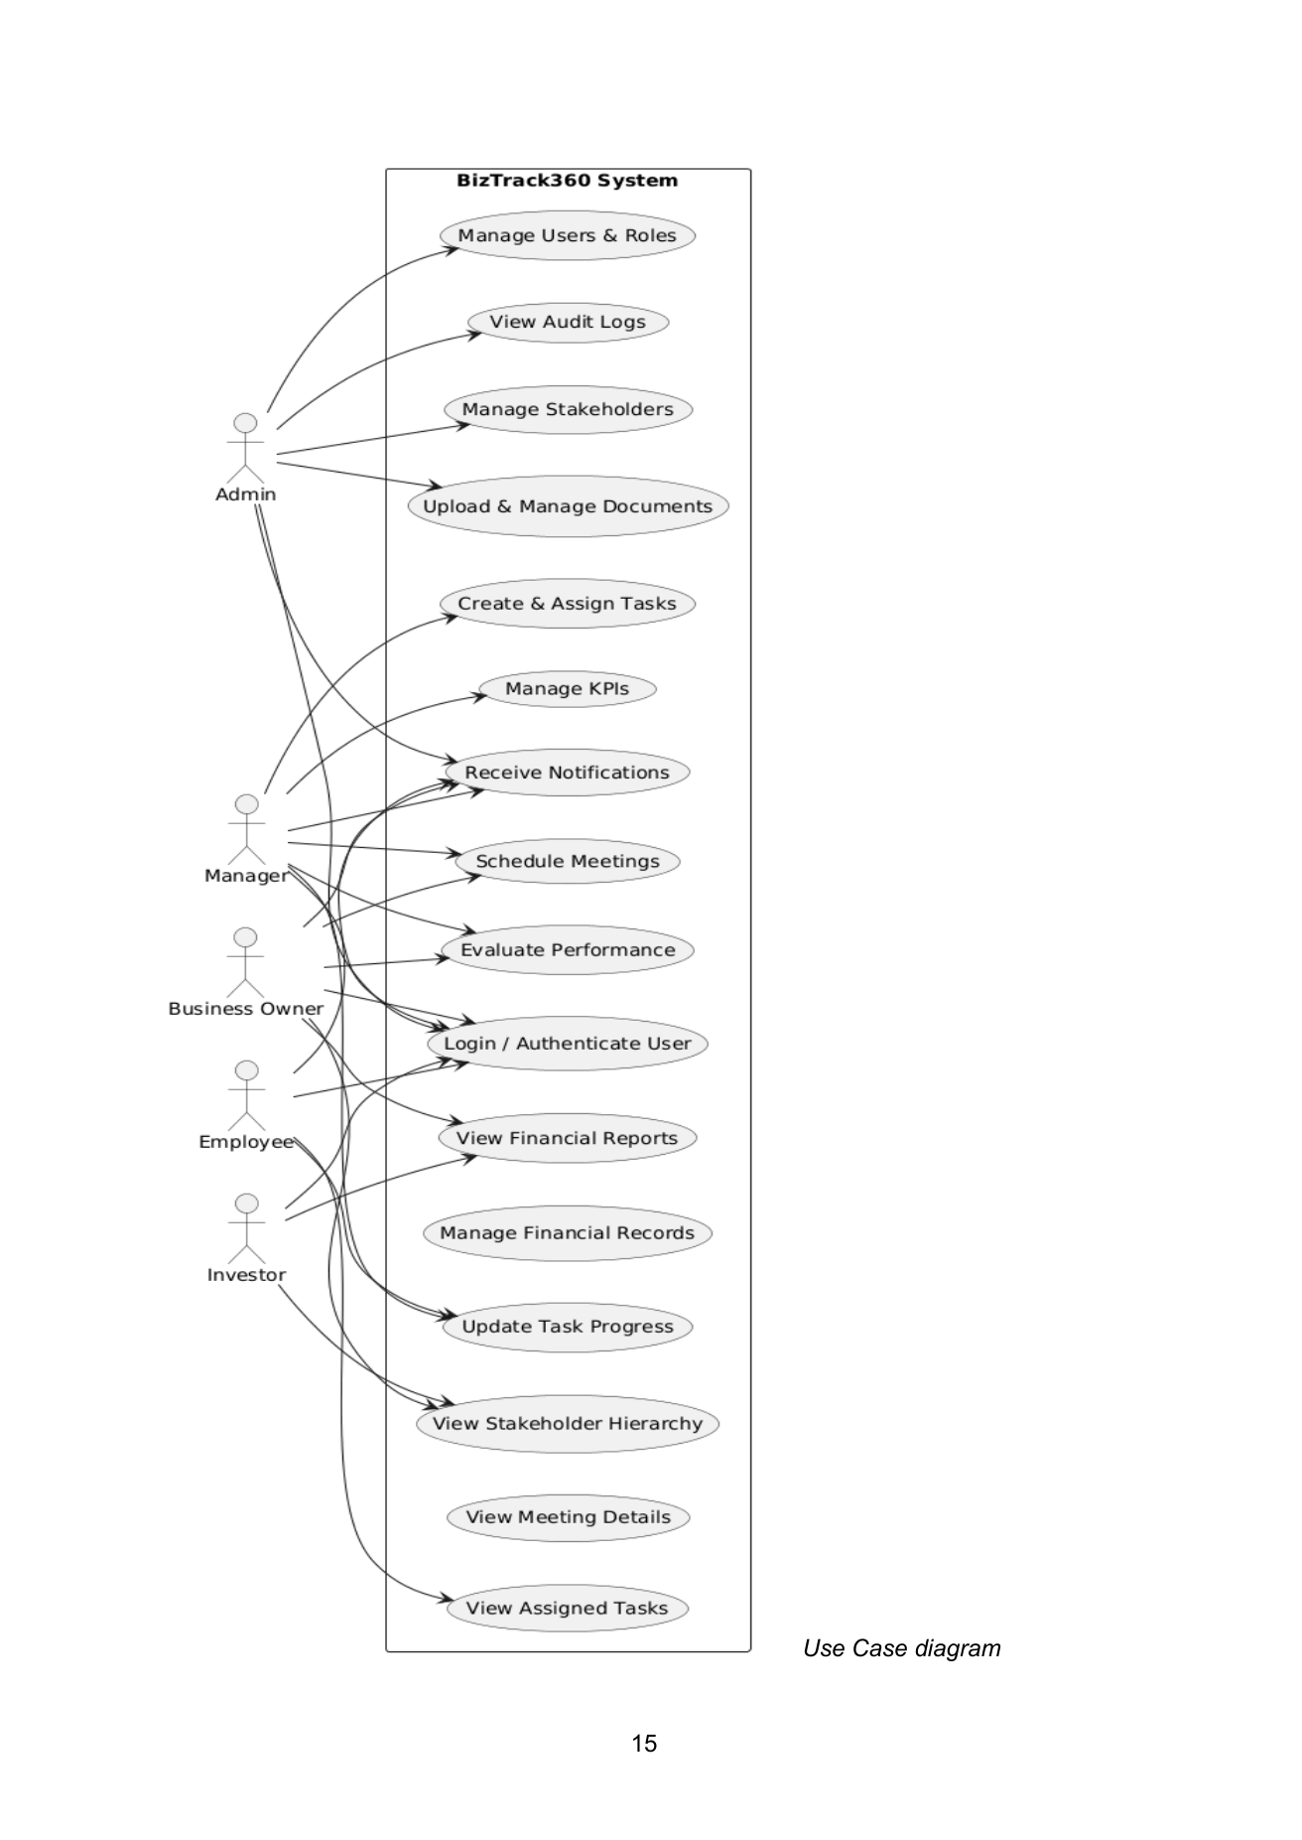

2. Sequence Diagram

Purpose / Description
Provides the interaction sequence that the frontend must support between Manager, Employee and System during task handling.

Detailed Artifact Content from the SRS
- Manager creates a task through the system.
- The task is stored.
- The assigned employee receives a notification.
- Employee views the task.
- Employee updates progress.
- System receives the progress update.
- Task status is updated.
- These interactions correspond to task-creation, task-viewing, notification and progress-update UI flows.

Related SRS Requirements
- Users must be authenticated before accessing the system.
- Access must be restricted according to user roles/permissions.
- Task information, progress and status must be stored and tracked.
- System activities must be traceable through activity logs.
- Sensitive data and files must be securely stored.

Original Diagram from SRS (Page 18)
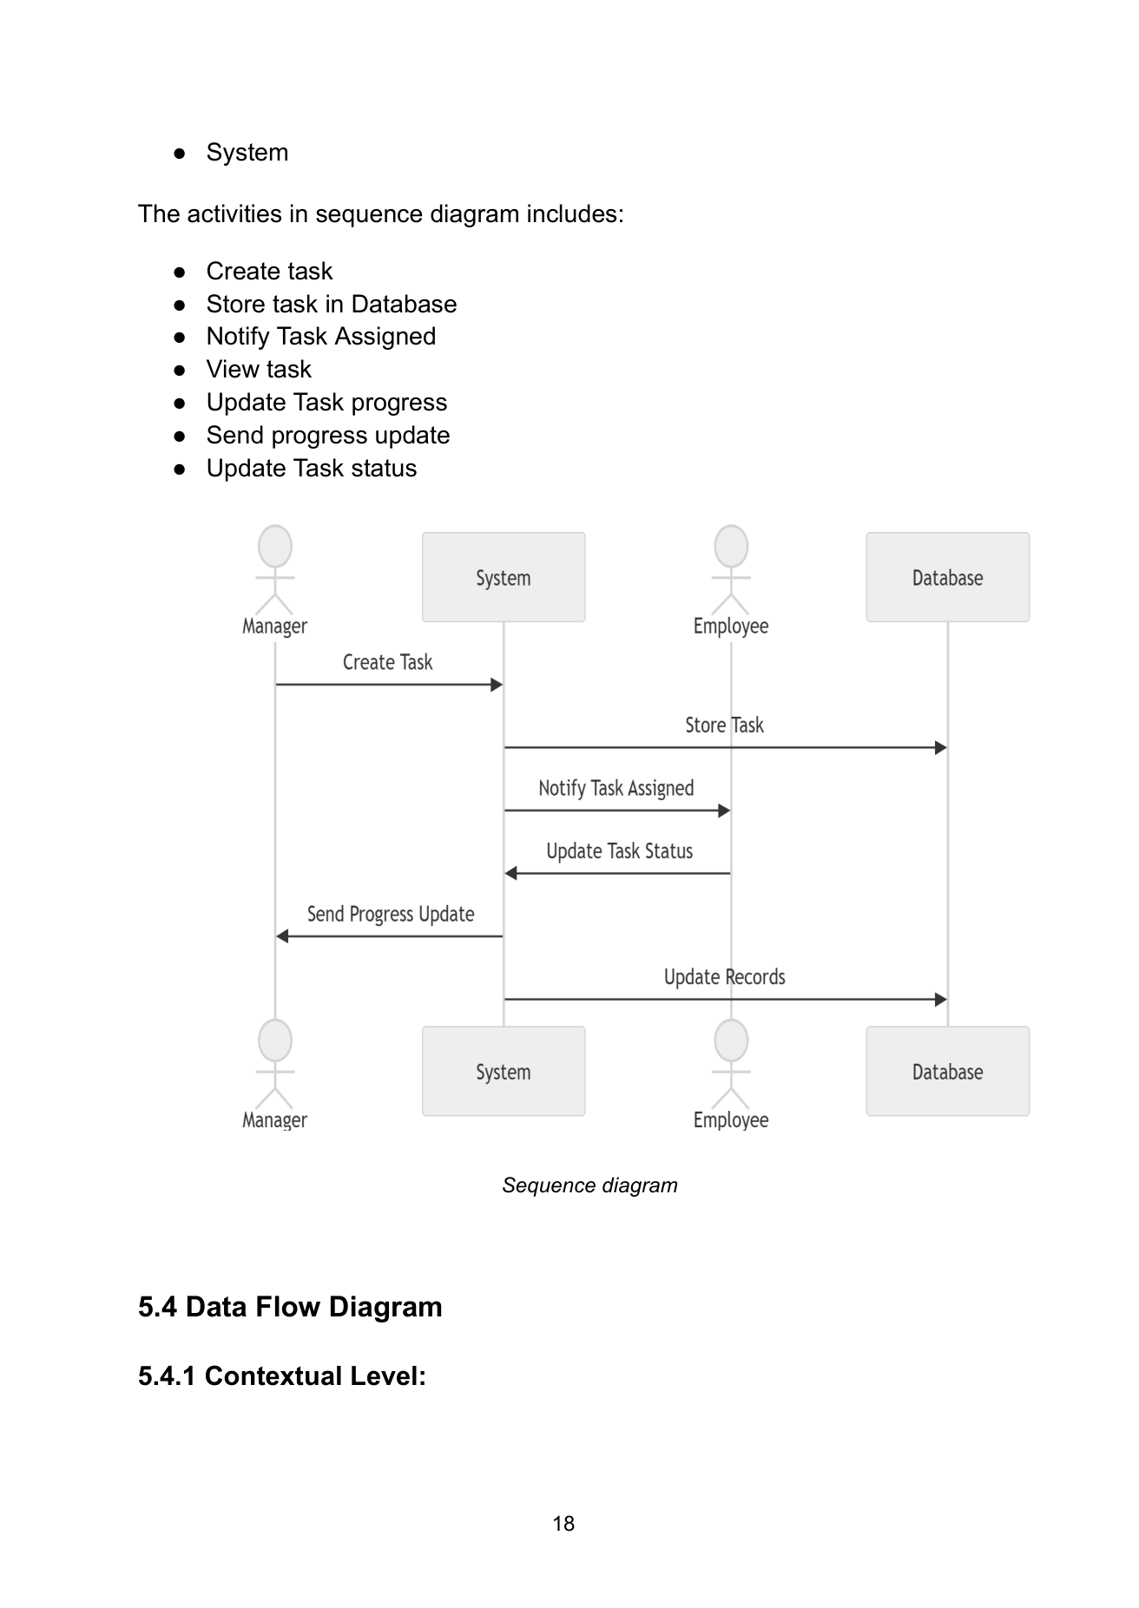

3. Activity Diagram — Task Workflow

Purpose / Description
Defines the user-facing flow from authentication and dashboard access to task completion, KPI updates, reports and notifications.

Detailed Artifact Content from the SRS
- Login and authentication form the first interaction.
- Failed authentication ends the workflow.
- Successful login opens the dashboard.
- Task creation and assignment follow.
- Employee views and works on the assigned task.
- Progress can be updated repeatedly.
- Completion causes KPI/report updates and stakeholder notifications.

Related SRS Requirements
- Users must be authenticated before accessing the system.
- Access must be restricted according to user roles/permissions.
- Task information, progress and status must be stored and tracked.
- System activities must be traceable through activity logs.
- Sensitive data and files must be securely stored.

Original Diagram from SRS (Page 23)
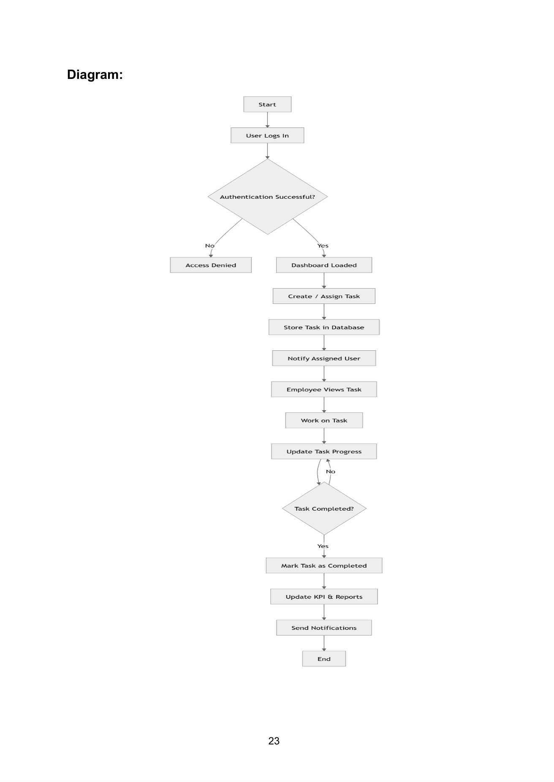

4. State Chart Diagram — Task Lifecycle

Purpose / Description
Shows the visible lifecycle/status progression of a task.

Detailed Artifact Content from the SRS
- Created: task is first defined.
- Assigned: responsibility is given to a specific user.
- In Progress: work begins.
- On Hold: task is temporarily paused because of an obstacle.
- Under Review: work is ready for evaluation.
- If changes are required, the task returns to In Progress.
- If approved, the task becomes Completed.
- Completed tasks move to Archived for long-term storage and record keeping.

Related SRS Requirements
- Tasks must be assignable and trackable.
- Task progress and status must be maintained.
- Notifications should be generated for relevant events.

Original Diagram from SRS (Page 24)
